Register Number: _____________________

DHANALAKSHMI SRINIVASAN ENGINEERING COLLEGE, PERAMBALUR – 621 212
(AUTONOMOUS)

DEPARTMENT OF AERONAUTICAL ENGINEERING

U20AE502/ Aircraft Structures
ASSESSMENT TEST – II
Year /Semester: III / V Date:
Duration: 90 minitues Total Marks: 60
Part A: 10 X 2 = 20 Marks
Answer all the questions
1 | Explain a concept of stiffened panel? | 2 | CO3 | BTL2
2 | List out the buckling modes of a thin walled section. | 2 | CO3 | BTL2
3 | Write the assumptions of plate theory? | 2 | CO3 | BTL2
4 | Define stress resultants. | 2 | CO3 | BTL2
5 | What is Bredt-Batho formula? | 2 | CO3 | BTL2
6 | What is semi tension field beam? | 2 | CO4 | BTL2
7 | Define Shear Centre and Shear Flow. | 2 | CO4 | BTL2
8 | Define Shear stress. | 2 | CO4 | BTL2
9 | Write the formulas for moment of inertia? | 2 | CO4 | BTL2
10 | Mark shear centre for thin walled equal angle section and T-section. | 2 | CO4 | BTL2

Part B: 2 X 13=26; 1X14=14=40 Marks
Answer all the questions
11 | a | i | Determine the shear flow distribution in the thin-walled Z section as shown in figure, due to a shear load Sy applied through the shear center of the section.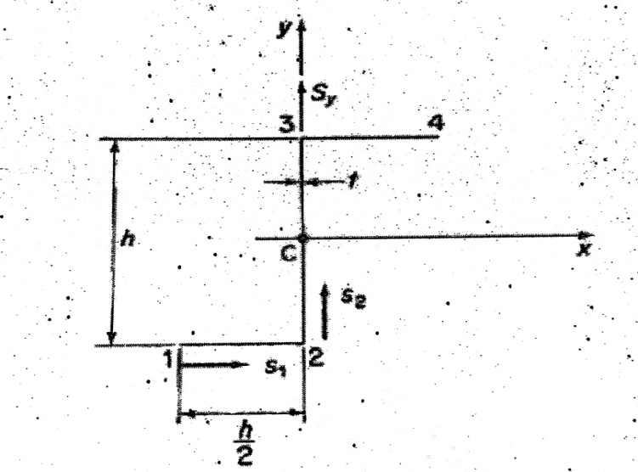 | 13 | CO3 | BTL3
11 | Or
11 | b | ii | A Find the Shear Flow Distribution and maxmimum shear flow.  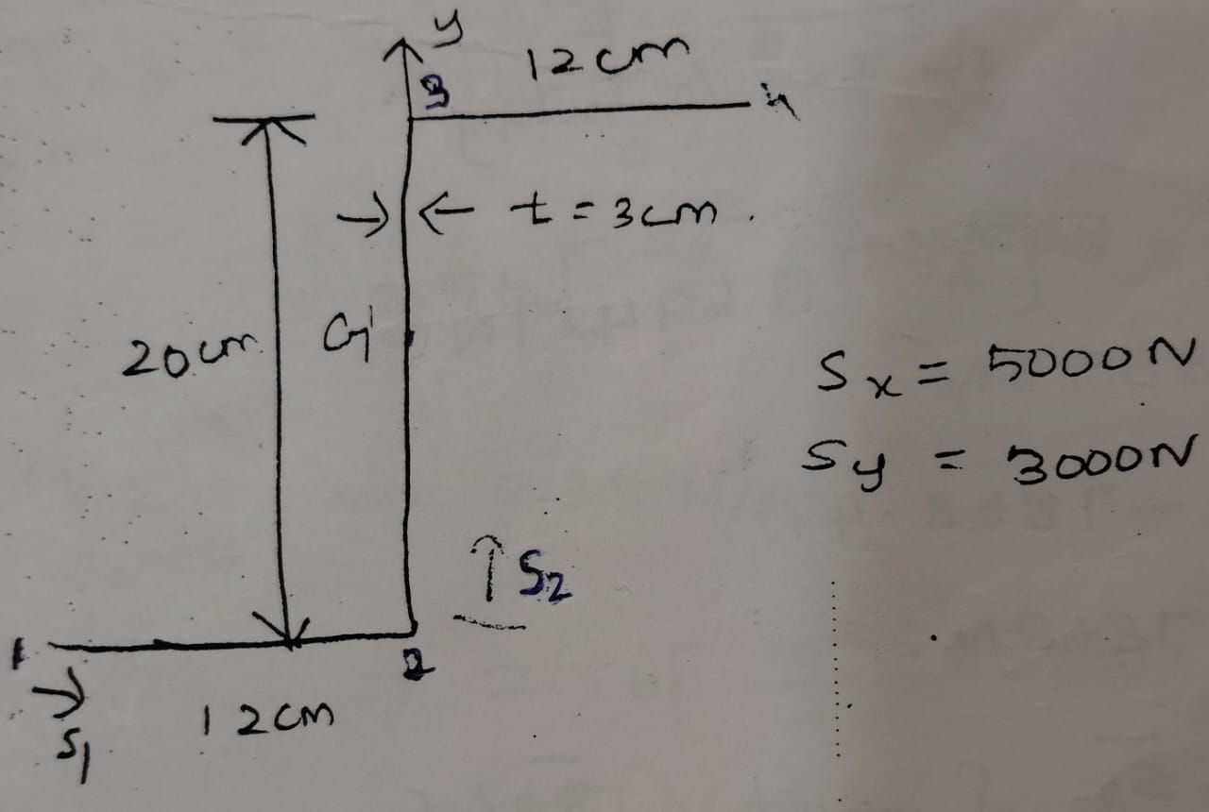 | 13 | CO3 | BTL4
12 | a | i | Plot the sher flow distribution given open section, Sx= 1200 N Sy= 1400 N through the shear center.Wall ineffective in bending.  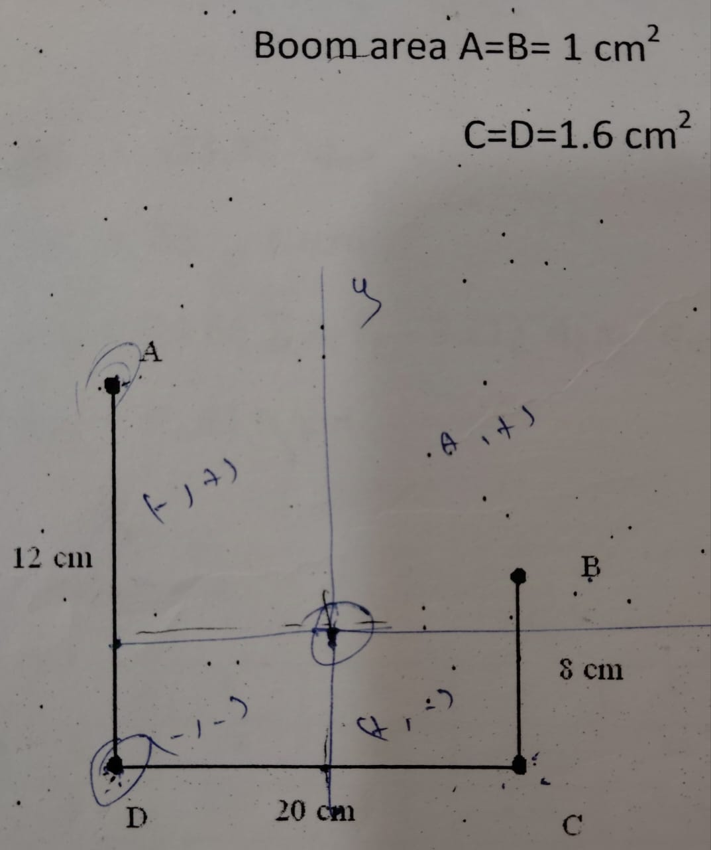 | 13 | CO3 | BTL4
12 | Or
12 | b | ii | Plot the shear flow distribution given open section a vertical load of 10 KN acts through the shear centre. Wall ineffective in bending.  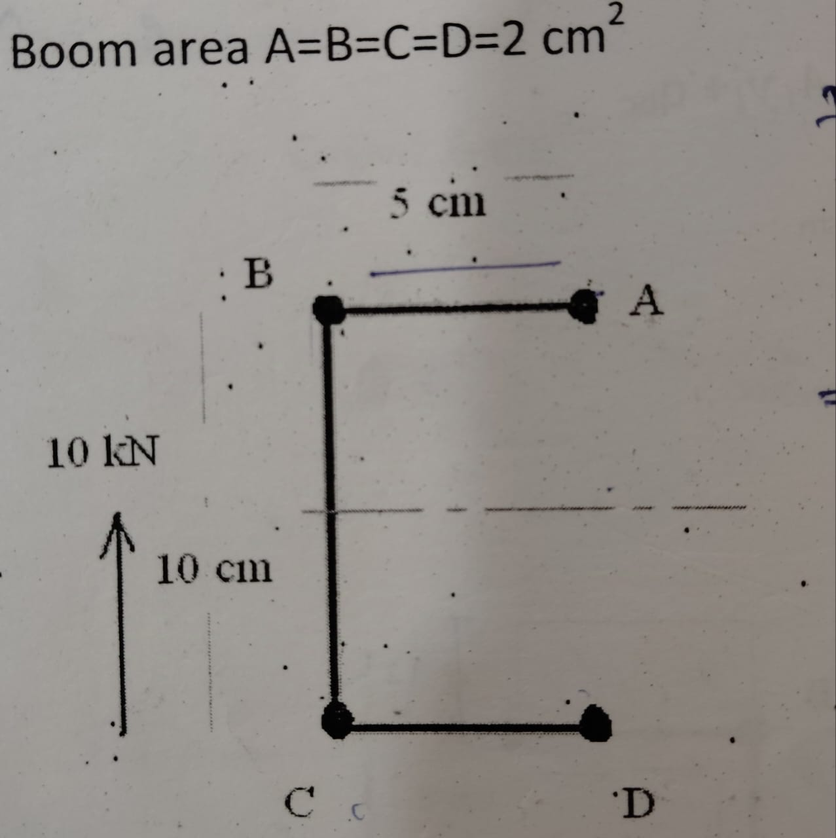 | 13 | CO3 | BTL4
13 | a | i | Find the shear flow for open section through the shear centre. Wall ineffective in bending 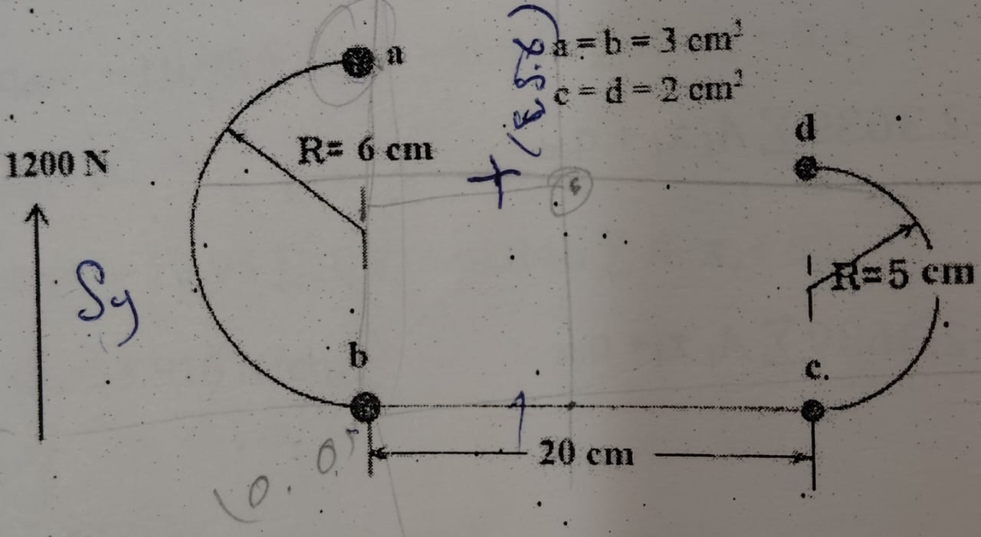 | 14 | CO4 | BTL3
13 | or
13 | b | ii | Find the shear and angle twist for given for multicell.  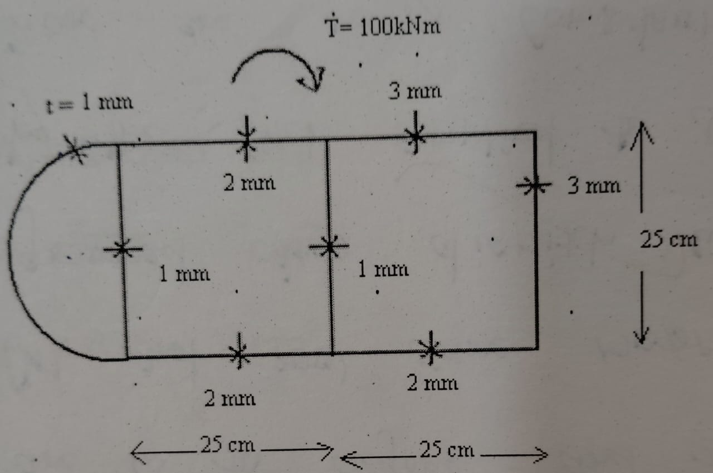 | 14 | CO4 | BTL3

Prepared by Verified by

